ESL Holiday Lesson Plan: “Sleigh Ride” Song Lyrics

Teacher:
Amy E. Lingenfelter

English Proficiency Level/s:
High beginner to high intermediate

Time:
50 min – 90 minutes (depending on homework and English proficiency level)

Objectives- Students will be able to:
- Define new key vocabulary (contextualized in song lyrics) in their own words and express orally and in writing how these words convey certain literary moods.
- Define mood in a literary work, produce examples from other works read, and accurately identify mood conveyed in song lyrics heard/read by completing a graphic organizer.
- Listen to/read song lyrics and identify/distinguish phonemes of known and new vocabulary in the lyrics and write them to complete the lyrics.
- Produce visual imagery conveying mood and meaning of new vocabulary words.
- Write their own sentences describing a situation in their lives that invokes the same mood as the song “Sleigh Bells” using new vocabulary words.

NY State Standards Fulfilled:
- Standard 1: Students will listen, speak, read, and write in English for information and understanding.
- Standard 2: Students will listen, speak, read, and write in English for literary response, enjoyment, and expression.
- Standard 5: Students will demonstrate cross-cultural knowledge and understanding.

Procedures:
- Introduce meaning of vocabulary using definitions, pictures, and model sentences via “Vocabulary Descriptions.” (10 min)
- Explain vocabulary guessing game and T models a few examples. In pairs, Ss guess word based on verbal description of their partner in his/her own words without stating the actual word. (8 min)
- Introduce and define “mood” in a literary work. Using a T-chart, elicit from Ss examples of how other works we’ve read elicited mood. Ask Ss to predict: “what mood do you think some of these vocab words suggest?” Ask Ss to think about mood as they listen to the song lyrics. (8 min)
- Hand out “Sleigh Ride Lyrics” with blanks for vocab words, which Ss must fill in as they listen carefully. Play 3 times to allow Ss to complete. Review by writing on the board the last time (10 min)
- Ask Ss: “what kind of mood did words and phrases from “Sleigh Ride” make you feel?” (8 min)
Pass out “Graphic Organizer: Lyric/Poem Mood Comprehension and explain. Model the first few examples and Ss complete the rest independently. (10 min)
- Pass out “Four-Square Vocabulary Worksheet” and explain. Ss write sentences about a situation in their life that evoked a similar mood using 6 vocab words they are least familiar with (they can complete for HW). (3-25 min)

Assessment (informal):
- Vocabulary guessing game (understanding of word meaning)
- Graphic Organizer: Lyric/Poem Mood (understanding of lyrics’ mood and word meaning in context)
- Four-Square Vocabulary Worksheet (application of word and literary mood to real-life context)
Key Vocabulary:

- Cozy (adjective)- warm and comfortable
“I like to feel cozy when I watch movies, so I sit on my couch with a blanket.”

- Chestnut (noun)- a reddish brown nut people eat especially during holidays
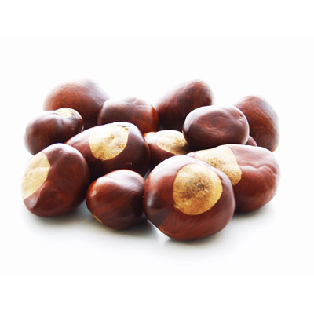
“My family eats roasted chestnuts every Christmas and Thanksgiving.”

- Fairy (noun)- a tiny flying woman with magical powers, popular in children’s stories
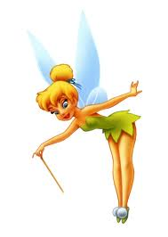
“In American culture, children put their baby tooth under their pillow for the
Tooth Fairy to replace the tooth with money.”

- Glide (verb)- to move easily, quietly, without trying hard
“We glided down the ice without falling when we went ice skating.”

- Grand (adjective)- great, wonderful, idealistic (old fashioned)
“The Grand Canyon is the most beautiful sight I’ve ever seen.”

- Lovely (adjective)- beautiful, satisfying to the eye, heart, or mind
”That is such a lovely photo of you in that beautiful dress!”

- Nearly (adverb)- almost
“I nearly fell down when I slipped on the ice.”

- Sleigh (noun) - a vehicle used for transporting people over snow or ice, sometimes by horses.

“We need a sleigh with horses to get through this heavy snow!”

- Snuggle (verb) - to cuddle with someone/something; to press closely next to someone/something for comfort or affection.

“I like to snuggle with my dog while watching TV.”

- “Giddy-up!” (command verb) - a command people use to get a horse to go faster.
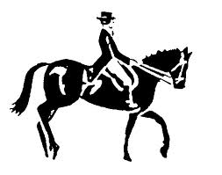
- “Two birds of a feather” (expression)- two people/things that are similar in
some way
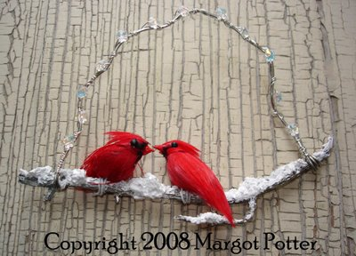
“My best friend and I are two birds of a feather- we are like twins!”

- “Currier & Ives-” artists who made pictures of everyday American life in
the 1800s
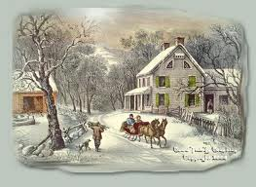 (Example of a Currier & Ives picture print)
“Sleigh Ride”
Music and Lyrics by Johnny Mathis

Directions: Please fill in the blanks with the words you hear.

- Just _________ those _________ bells jingling, ring-ting-tingling too
- ___________, it's ________ weather for a ________ ride together with you
- Outside the _________ is falling and friends are calling "You-hoo!"
- ___________, it's ________ weather for a ________ ride together with you

- Giddy-up, giddy-up, giddy-up, _________, let's look at the show
- We're riding in a wonderland of _________.
- Giddy-up, giddy-up, giddy-up, it's _________, just holding your hand
- We're _________ along with a song of a wintery _________ land

- Our cheeks are ________ and rosy and comfy _________ are we
- We've _________ close _________ like two birds of a feather would be
- Let's take that road before us and sing a chorus or two
- __________, it's ________ weather for a _________ ride together with you

- There's a birthday __________ at the home of Farmer Gray
- It'll be the perfect ending of a perfect _________
- We'll be singing the _________ we love to sing without a single stop
- At the fireplace where we'll watch the _________ pop
- Pop! Pop! Pop!

- There's a __________ feeling nothing in the world can buy
- When they pass around the __________ and the pumpkin pie
- It'll _________ be like a _________ print by Currier and Ives
- These wonderful things are the things we __________ all through our li-ives
- These wonderful things are the things we __________ all through our lives

- Just _________ those _________ bells jingling, ring-ting-tingling too
- __________, it's ________ weather for a _________ ride together with you
- Outside the __________ is falling and friends are calling "You-hoo!"
- __________, it's ________ weather for a _________ ride together with you

- Giddy-up, giddy-up, giddy-up, __________, let's look at the show
- We're riding in a wonderland of ___________.
- Giddy-up, giddy-up, giddy-up, it's _________, just holding your hand
- We're _________ along with a song of a wintery _________ land

- ________ and rosy and comfy _________ are we
- We've _________ close _________ like two birds of a feather would be
- Let's take that road before us and sing a chorus or two
- __________, it's ________ weather for a _________ ride together with you
- _________ weather for a _________ ride together with you
- _________ weather for a _________ ride together with. . .
- _________ weather for a _________ ride together with. . .
- _________ weather for a _________ ride together with. . .

Graphic Organizer: Lyric/Poem Mood Comprehension
Directions: Please write vocab words/phrases/lines from “Sleigh Bells” lyrics and the corresponding mood these words create:

Words / Phrases / Lyric Line | Mood
- Sleigh bells ringing, jingling too  - “Giddy-up, Giddy-up, Giddy-up, let’s go!”  - Gliding along | Happy movement
- Cozy
- Snow is falling
- Lovely weather
- Wonderland
- Wintery fairy land
- Friends are calling “Yoo-hoo!”

- It’ll nearly be like a picture print by Currier & Ives
- At the fireplace
- Chestnuts pop! pop! pop!
- It’s grand just holding your hand
- We’ve snuggled close together
- Like two birds of a feather

Literary Terms
MOOD
The mood is the feeling created in a literary work (song, poem, story, etc.). The choice of setting, objects, actions of the characters/people, details, pictures, and words all create a specific mood. For example, an author may create a mood of sadness in a story about a little boy who dies. The mood of the work often makes the reader feel the emotion that the author is trying to express.

