Country Comparison Chart
Topic: Regime and Government
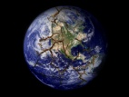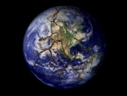 | Executive? (Type? / Parts? / How elected?) | Legislative? (Type? / Parts? / How elected?) | Checks and Balances / Power- Sharing? | Type of government /economic system? | Historical influence on current regime? | Written laws/  Constitu-tion? | Corruption? (If: Kind?) | Other:  _______  _______
U.K.
Germany
France
Mexico
Brazil
Russia
China
India
Nigeria
Iran

