Country Comparison Chart
Topic: Class and Class Structure
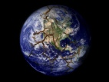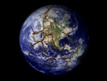 | Economic equality  (gap between classes)  High, Medium,  Low | Capitalist Economic Development Occurring?  Already developed, Developing, Not developing | Wealth distribution: underclass  (Low, Medium, High) | Wealth distribution: working class  (Low, Medium, High) | Wealth distribution: middle class  (Low, Medium, High) | Wealth distribution: upper class  (Low, Medium, High) | Urban vs. Rural:  social class distribution & distinction  High distinction, Medium distinction,  Low distinction | Other things specific to this country  (Anything extra)
U.K.
Germany
France
Mexico
Brazil
Russia
China
India
Nigeria
Iran

