Country Comparison Chart
Topic: Political Culture and Ideology
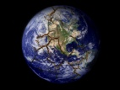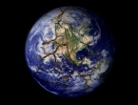 | Collectivistic or Individualistic political culture? | Attitude/beliefs towards security vs. freedom? | Attitude/beliefs towards hierarchy, order, and authority? | Attitude/beliefs towards political/system legitimacy? | Level of attachment to the political community? | Collectivistic or Individualistic general culture?
U.K.
Germany
France
Mexico
Brazil
Russia
China
India
Nigeria
Iran

