Country Comparison Chart
Topic: Political Culture and Ideology
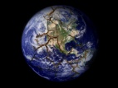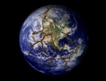 | Collectivistic or Individualistic political culture? | Attitude towards security vs. freedom? | Attitude towards hierarchy, order, and authority | Attitude towards political/system legitimacy | Level of attachment to the political community? | OTHER
U.K.
Germany
France
Mexico
Brazil
Russia
China
India
Nigeria
Iran

