Country Comparison Chart
Topic: Identity Structures
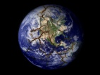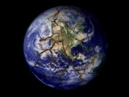
U.K.
Germany
France
Mexico
Brazil
Russia
China
India
Nigeria
Iran

