ENL Standalone Holiday Lesson Plan:
“Sleigh Ride” Song Lyrics & Literary Element “Mood”

Teacher:
Amy E. Quinde, English as a New Language (ENL)

English Proficiency Level/s:
Entering and Emerging (“True” Beginner to High Beginner). It can also be adapted to higher levels.

Time:
40 min – 90 minutes (depending on homework and English proficiency level).

Objectives- Students will be able to (SWBAT):
- Define new key vocabulary (contextualized in song lyrics) in their own words and express orally and in writing how these words evoke certain literary moods (completed before and after the lesson).
- Define mood in a literary work, produce examples from other works read, and accurately identify mood conveyed in song lyrics heard/read by completing a graphic organizer.
- Listen to/read song lyrics and identify/distinguish phonemes of known and new and known vocabulary in the lyrics and write them to complete the lyrics.
- Produce visual imagery conveying mood and meaning of new vocabulary words (homework).
- Write their own sentences describing a song, movie, or literary work in their lives that invokes the same mood as the song “Sleigh Bells” using new vocabulary words (homework/follow-up lesson).

Connection with English Language Arts (ELA) and Regents Curriculum:
- One of the goals of my standalone is to reinforce and supplement the curriculum in students’ ELA Regents courses with the goal of heightening comprehension, reinforcement and scaffolding of language skills, developing Tier 2 and Tier 3 vocabulary, and allowing more time for completion in an anxiety-free environment.
- I typically teach the same skills learned in ELA using different, more accessible (or sometimes identical) text compared to that of the general education students in the class.
- For the English Language Arts Regents curriculum and Nicole Abate’s ELA class where I push in Period 3 (all students in my standalone take ELA with her), students must identify ways in which author uses certain literary elements to convey a theme, central idea, and/or main point. Students are currently reading “The Souls of Black Folk” in which author use of tone and mood convey significance of identity. Students have been asked to differentiate between tone and mood and identify text elements that convey both in “The Souls of Black Folk” to reinforce the central idea of “identity.” The goal of this lesson is to reinforce the understanding and application of literary element “mood” via a fun a catchy song that will clearly drive home the concept of “mood.”

NY State Standards Fulfilled:
- Standard 1: Students will listen, speak, read, and write in English for information and understanding.
- Standard 2: Students will listen, speak, read, and write in English for literary response, enjoyment, and expression.
- Standard 5: Students will demonstrate cross-cultural knowledge and understanding.

Procedures:
- Bellwork: Think about some Christmas songs you have heard. What are they? (Write down some words you remember). How do they make you feel? (Write 1-2 sentences please).
- (Done the lesson before) Introduce meaning of key vocabulary presented in “Sleigh Ride” song lyrics using definitions, pictures, and model sentences. (15 min)
- (Done the lesson before) Explain vocabulary guessing game and T models a few examples. In pairs, Ss guess word based on partner’s verbal description, gesture, or drawing of the word (they must not state the actual word). (15 min)
- Introduce and define “mood” in a literary work. Using a T-chart, elicit from Ss examples of how other works we’ve read or movies they seen elicited mood (if they don’t offer, ask them to provide mood of “Going Home to Ecuador” or “The Walking Dead”). Ask Ss to predict: “what mood do you think some of these vocab words we learned suggest?” Ask Ss to think about mood as they listen to the song lyrics. (8 min)
- Review the Word Bank for the “Sleigh Ride” Fill-in-the-Blanks and model pronunciation (5 min)
- Hand out “Sleigh Ride Lyrics” with blanks for vocab words, which Ss must fill in as they listen carefully while referring to the word bank. Play 3 times to allow Ss to complete. Review by writing the words on the board the last time (10 min)
- Ask Ss: “what kind of mood did words and phrases from “Sleigh Ride” make you feel?” (8 min)
Pass out “Graphic Organizer: Lyric/Poem Mood Comprehension and explain. Model the first few examples and Ss complete the rest independently. (10 min)
- Pass out “Four-Square Vocabulary Worksheet” and explain, modeling example sentences. Ss write sentences about a situation in their life that evoked a similar mood using vocab “mood” words: “cozy, fairy, glide, grand, lovely, sleigh, snuggle, giddy-up,” and “two birds of a feather” (they can complete this for HW). (3-25 min)

Vocabulary:
- Cozy, fairy, glide, grand, lovely, sleigh, snuggle, giddy-up, “two birds of a feather”

Materials:
- List of key vocabulary with definitions
- Student notebooks
- Aspire software and Smartboard
- YouTube song & video, “Sleigh Ride:” https://www.youtube.com/watch?v=FnTA70YWuMM
- Word Bank for “Sleigh Ride” Fill-in-the-Blanks
- Fill-in-the-Blanks Song Lyrics for “Sleigh Ride” Song
- Graphic Organizer: Lyric/Poem Mood Comprehension
- Four-Square Vocabulary Worksheet

Assessment (informal):
- Vocabulary guessing game (understanding of word meaning)
- Graphic Organizer: Lyric/Poem Mood Comprehension (understanding of lyrics’ mood and word meaning in context)
- Four-Square Vocabulary Worksheet (application of word and literary mood to real-life context. This could be homework or a follow-up activity).

Key Vocabulary:

- Cozy (adjective)- warm and comfortable
“I like to feel cozy when I watch movies, so I sit on my couch with a blanket.”

- Fairy (noun)- a tiny flying woman with magical powers, popular in children’s stories
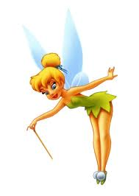
“In American culture, children put their baby tooth under their pillow for the
Tooth Fairy to replace the tooth with money.”

- Glide (verb)- to move easily, quietly, without trying hard
“We glided down the ice without falling when we went ice skating.”

- Grand (adjective)- great, wonderful, idealistic (old fashioned)
“The Grand Canyon is the most beautiful sight I’ve ever seen.”

- Lovely (adjective)- beautiful, satisfying to the eye, heart, or mind
”That is such a lovely photo of you in that beautiful dress!”

- Sleigh (noun) - a vehicle used for transporting people over snow or ice, sometimes by horses.

“We need a sleigh with horses to get through this heavy snow!”

- Snuggle (verb) - to cuddle with someone/something; to press closely next to someone/something for comfort or affection.
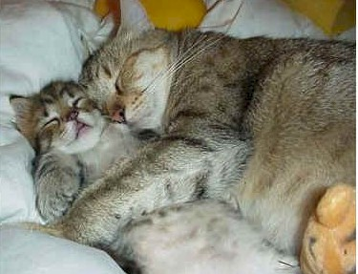
“I like to snuggle with my dog while watching TV.”

- “Giddy-up!” (command verb) - a command people use to get a horse to go faster.
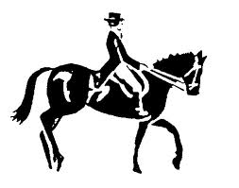

- “Two birds of a feather” (expression)- two people/things that are similar in
some way
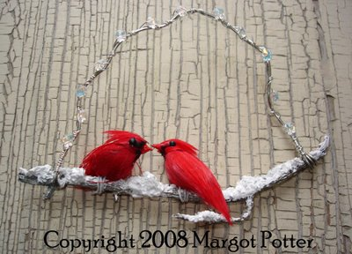
“My best friend and I are two birds of a feather- we are like twins!”

Word Bank (“Sleigh Ride” Fill-in-the-Blanks)

- Cozy | - Come on | - Together
- Fairy | - Let’s go | - Nice
- Gliding | - Happy | - Day
- Grand | - Coffee | - Hear
- Lovely | - Snow | - Party
- Sleigh | - Picture | - Songs
- Snuggled | - Remember

“Sleigh Ride”
Music and Lyrics by Johnny Mathis

Directions: Please fill in the blanks with the words you hear.

- Just _________ those _________ bells jingling, ring-ting-tingling too
- ___________, it's ________ weather for a ________ ride together with you
- Outside the _________ is falling and friends are calling "You-hoo!"
- ___________, it's ________ weather for a ________ ride together with you

- Giddy-up, giddy-up, giddy-up, _________, let's look at the show
- We're riding in a wonderland of _________.
- Giddy-up, giddy-up, giddy-up, it's _________, just holding your hand
- We're _________ along with a song of a wintery _________ land

- Our cheeks are ________ and rosy and comfy _________ are we
- We've _________ close _________ like two birds of a feather would be
- Let's take that road before us and sing a chorus or two
- __________, it's ________ weather for a _________ ride together with you

- There's a birthday __________ at the home of Farmer Gray
- It'll be the perfect ending of a perfect _________
- We'll be singing the _________ we love to sing without a single stop
- At the fireplace where we'll watch the chestnuts pop
- Pop! Pop! Pop!

- There's a __________ feeling nothing in the world can buy
- When they pass around the __________ and the pumpkin pie
- It'll nearly be like a _________ print by Currier and Ives
- These wonderful things are the things we __________ all through our li-ives
- These wonderful things are the things we __________ all through our lives

- Just _________ those _________ bells jingling, ring-ting-tingling too
- __________, it's ________ weather for a _________ ride together with you
- Outside the __________ is falling and friends are calling "You-hoo!"
- __________, it's ________ weather for a _________ ride together with you

- Giddy-up, giddy-up, giddy-up, __________, let's look at the show
- We're riding in a wonderland of ___________.
- Giddy-up, giddy-up, giddy-up, it's _________, just holding your hand
- We're _________ along with a song of a wintery _________ land

- ________ and rosy and comfy _________ are we
- We've _________ close _________ like two birds of a feather would be
- Let's take that road before us and sing a chorus or two
- __________, it's ________ weather for a _________ ride together with you
- _________ weather for a _________ ride together with you
- _________ weather for a _________ ride together with. . .
- _________ weather for a _________ ride together with. . .
- _________ weather for a _________ ride together with. . .

Literary Terms
MOOD
The mood is the feeling created in a literary work (song, poem, story, etc.). The mood of the work often makes the reader feel the emotion that the author is trying to express. The choice of setting, objects, actions of the characters/people, details, pictures, and words all create a specific mood. For example, an author may create a mood of sadness in a story about a little boy who dies.

Graphic Organizer: Lyric/Poem Mood Comprehension
Directions: Please write vocab words/phrases/lines from “Sleigh Bells” lyrics and the corresponding mood these words create for you:

Words / Phrases / Lyric Line | Mood that it puts you in
- Sleigh bells ringing, jingling too  - “Giddy-up, Giddy-up, Giddy-up, let’s go!”  - Gliding along | Happy movement
- Cozy
- Snow is falling
- Lovely weather
- Wonderland
- Wintery fairy land
- Friends are calling “Yoo-hoo!”

- It’ll nearly be like a picture print by Currier & Ives
- At the fireplace
- Chestnuts pop! pop! pop!
- It’s grand just holding your hand
- We’ve snuggled close together
- Like “two birds of a feather”
- Anything that YOU read or heard from the song lyrics ☺

