Country Comparison Chart
Topic: Economic Development
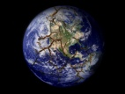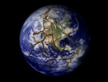
U.K.
Germany
France
Mexico
Brazil
Russia
China
India
Nigeria
Iran

