Culture Club: The US Dollar in Panama
How long has Panama been using the US Dollar?
Why did Panama start using the US Dollar?
Do you think it is a good thing that Panama is using the US Dollar?
Why are the Panamanian one-dollar coins called “Martinellis”?
Do you know who the people on US currency are?
Do you know what the buildings on US currency are?
How does using currency (money) from another country affect your Panamanian identity?

US Money Facts (adapted from http://mistupid.com/currency/)
- Lincoln faces to the right because the penny was an adaptation of a plaque.

- E Pluribus Unum means "Out of Many, One".

- On the back of a Roosevelt dime, the center torch signifies liberty. The oak branch to the right signifies strength and independence. The olive branch to the left signifies peace.

- On an American one dollar bill, there is an owl in the upper left-hand corner of the "1" encased in the "shield" and a spider hidden in the front upper right-hand corner.

- The law prohibits portraits of living persons from appearing on Government
Securities.

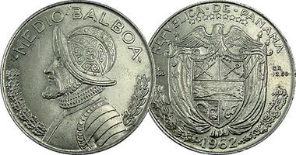
- Currency paper is composed of 25% linen and 75% cotton.

Abigail Bruhlmann | English Language Fellow, Panama | 2013-2014

US Coins (adapted from: http://mistupid.com/currency/)
Value | Image | Obverse | Reverse
Penny  1¢ | 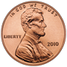 | Abraham Lincoln  16th U.S. President | The Lincoln Memorial  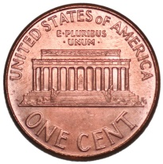
Nickel  5¢ | 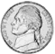 | Thomas Jefferson  3rd U.S. President | Monticello: Jefferson's home  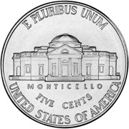
Dime  10¢ | 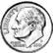 | Franklin Delano Roosevelt  32nd U.S. President | Olive Branch, Torch, Oak Branch.  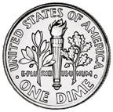
Quarter  25¢ | 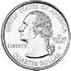 | George Washington  1st U.S. President | American Bald Eagle  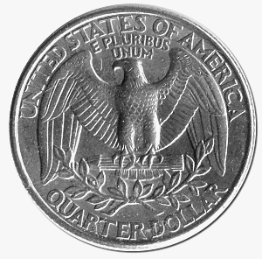
Half-Dollar  50¢ | 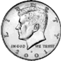 | John F. Kennedy  35th U.S. President | The Presidential Seal  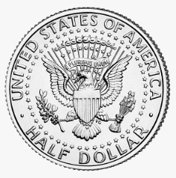
Silver Dollar  $1  Abigail Bruhlmann | English Language Fellow, Panama | 2013-2014 | 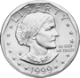 | Susan B. Anthony  Leader of the movement  to give women the right  to vote | Apollo 11 Insignia, Eagle  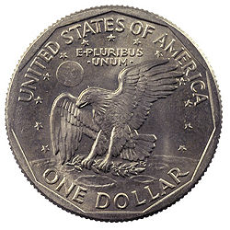
Golden Dollar  $1 | 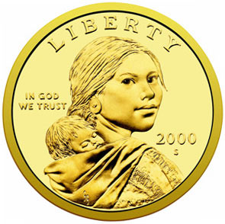 | Sacagawea  A Native American woman  who helped guide the  explorers Louis and Clark in  the Western US. | Soaring Eagle and 17 Stars  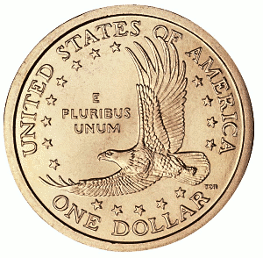
Currency (adapted from: http://mistupid.com/currency/)
$1 | 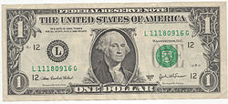 | George Washington  1st U.S. President | The Great Seal of the United States  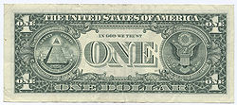
$5 | 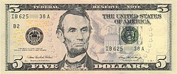 | Abraham Lincoln  16th U.S. President | Lincoln Memorial  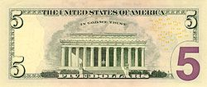
$10 | 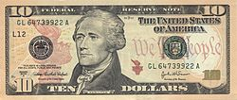 | Alexander Hamilton  1st U.S. Treasury Secretary | U.S. Treasury  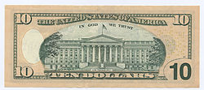
$20 | 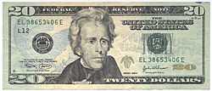 | Andrew Jackson  7th U.S. President | The White House  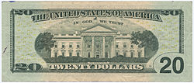
$50 | 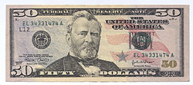 | Ulysses S. Grant  18th U.S. President  Civil War General | U.S. Capitol  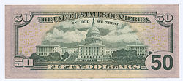
$100  Abigail Bruhlmann | English Language Fellow, Panama | 2013-2014 | 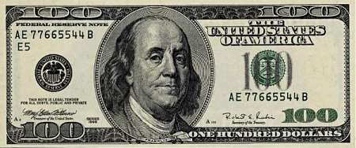 | Benjamin Franklin  One of the Founding Fathers  of the United States | Independence Hall  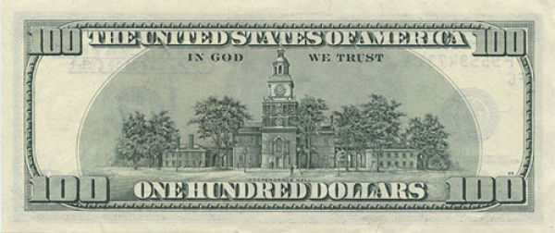

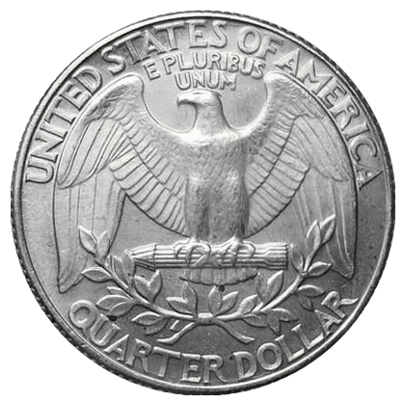
US State Quarters

The back of most quarters looks like this:

The eagle is a symbol of the United States.
E Pluribus Unum = Out of many, one.

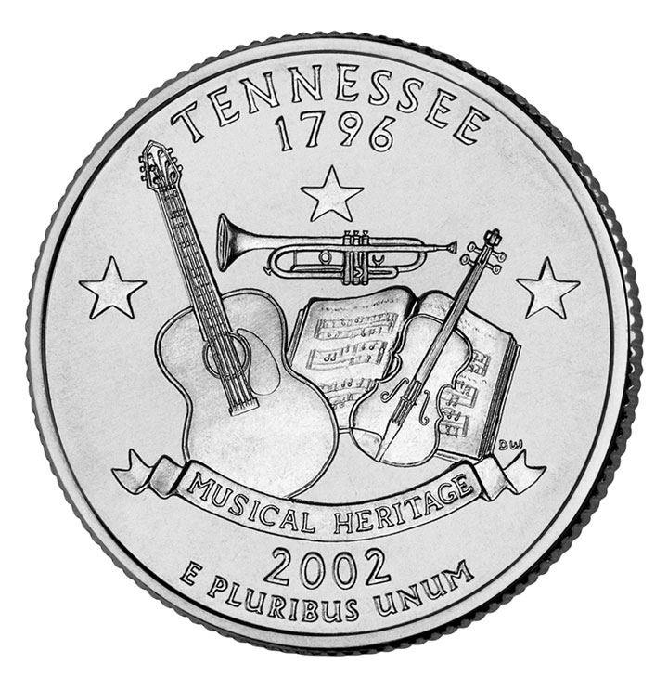
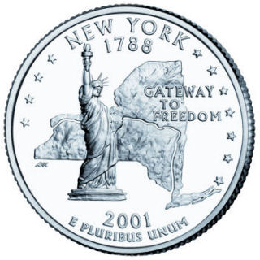
There is a special series of quarters that represents each of the 50 US states. The design of each state is unique to its history and culture. Here are some examples:
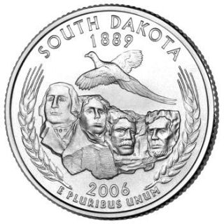
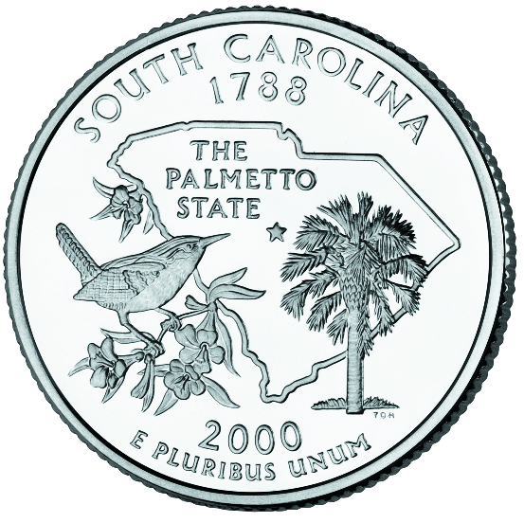
Abigail Bruhlmann | English Language Fellow, Panama | 2013-2014

Panamanian State Quarters

Which province are you from?

What makes its history and culture unique and special?

What are some images that symbolize your province?

Using the information above, draw your own Panamanian State Quarter below!

Abigail Bruhlmann | English Language Fellow, Panama | 2013-2014

