All Saints Day Web Quest
Conversation Level 12

Presentation for Friday, Nov 1st.

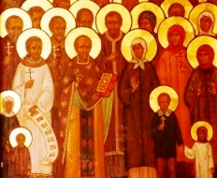
Directions: Prepare a 10-15 minute presentation to give the class by answering the following questions. Please include 3-5 images in your presentation to make it more interesting!

When is All Saints Day?
Why is All Saints Day celebrated?
Can you explain the history of All Saints Day?
What are the popular images of All Saints Day and why?
How is All Saints Day celebrated in the US?
How is it celebrated in Honduras? In other countries?
Do you think it is appropriate to celebrate it still today?
What are some concerns about celebrating this holiday?
What do you think of All Saints Day?

Look at the following websites, including images, videos and text:

http://www.medjugorje.ws/en/videos/all-saints-day/ | -This is a video on the history of All Saints Day.
http://www.churchyear.net/allsaints.html | - History and images of All Saints Day
http://en.wikipedia.org/wiki/All_Saints'_Day | - General information about All Saints Day
http://www.timeanddate.com/holidays/us/all-saints-day | - a short history of All Saints Day
http://www.stpaulskingsville.org/allsaints.htm | - another short article on the meaning of All Saints Day

Have fun, and feel free to find even more interesting information for your presentation. Please remember not to read while you're presenting!
See this website for a review:

http://www.usnews.com/education/blogs/professors-guide/2010/02/24/15-strategies-for-giving-oral-presentations

