Day of the Dead Web Quest
Conversation Level 12

Presentation for Friday, Nov 1st.

Directions: Prepare a 10-15 minute presentation to give the class by answering the following questions. Please include 3-5 images in your presentation to make it more interesting!
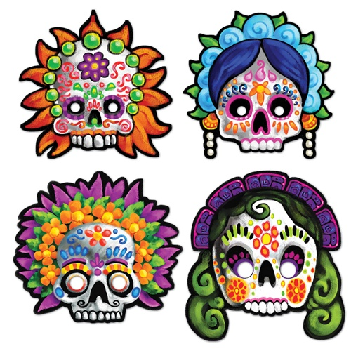
When is the Day of the Dead?
Why is the Day of the Dead celebrated?
Can you explain the history of the Day of the Dead?
What are the popular images of the Day of the Dead
and why?
How is the Day of the Dead celebrated in the US?
How is it celebrated in Honduras? In other countries?
Do you think it is appropriate to celebrate it still today?
What are some concerns about celebrating this holiday?
What do you think of the Day of the Dead?

Look at the following websites, including images, videos and text:

http://dsc.discovery.com/tv-shows/other-shows/videos/discovery-atlas-mexico-day-of-the-dead.htm | -This is a video on the history of the Day of the Dead. There are many more videos on this website.
http://www.huffingtonpost.com/2012/10/31/day-of-the-dead_n_2049351.html | - A slide show about the Day of the Dead in the US
http://en.wikipedia.org/wiki/Day_of_the_Dead | - General information about Day of the Dead
http://www.azcentral.com/ent/dead/articles/dead-history.html?nclick_check=1 | - a short history of Day of the Dead
http://www.ladayofthedead.com/history.html | - another short article on the meaning of Day of the Dead

Have fun, and feel free to find even more interesting information for your presentation. Please remember not to read while you're presenting!
See this website for a review:

http://www.usnews.com/education/blogs/professors-guide/2010/02/24/15-strategies-for-giving-oral-presentations

