Thanksgiving Web Quest
Conversation Level 12

Presentation for Friday, Nov 1st.

Directions: Prepare a 10-15 minute presentation to give the class by answering the following questions. Please include 3-5 images in your presentation to make it more interesting!
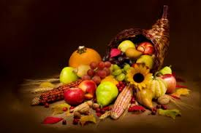
When is Thanksgiving?
Why is the Thanksgiving celebrated?
Can you explain the history of the Thanksgiving?
What are the popular images of Thanksgiving and why?
How is Thanksgiving celebrated in the US?
How is it celebrated in Honduras? In other countries?
Do you think it is appropriate to celebrate it still today?
What are some concerns about celebrating this holiday?
What do you think of Thanksgiving?

Look at the following websites, including images, videos and text:

http://www.history.com/topics/thanksgiving | -This is a video on the history of Thanksgiving. There are many more videos on this website.
http://www.plimoth.org/learn/MRL/read/thanksgiving-history | - An article about Thanksgiving with pictures
http://en.wikipedia.org/wiki/Thanksgiving | - General information about Thanksgiving
http://www.watchknowlearn.org/Category.aspx?CategoryID=3168 | - videos of Thanksgiving
http://holydays.tripod.com/thanks.htm | - the story of Thanksgiving

Have fun, and feel free to find even more interesting information for your presentation. Please remember not to read while you're presenting!
See this website for a review:

http://www.usnews.com/education/blogs/professors-guide/2010/02/24/15-strategies-for-giving-oral-presentations

