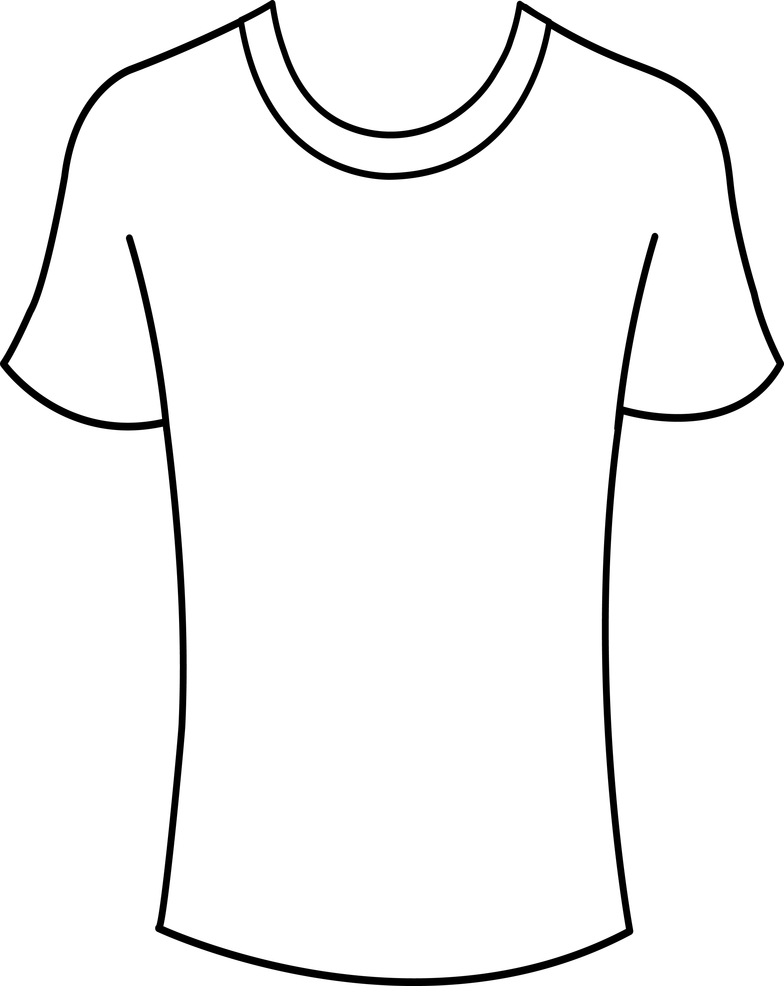
Activity: My Words
Directions: Brainstorm with students some nouns that have significance in their lives (such as movies, friends, music).
My Words
Ask student to write as many words as they can on their T-shirt (3-5 minutes).
Randomly pair students and ask them to explain their choices. Write frame on board, if necessary:
I chose “computer” because I love to post photos to Facebook.
I wrote “cell phone” because I like to text my friends.
(Extension: if materials are available, students could paint their words on an actual T-shirt, with their camp team name on the back. On the last day of camp students could vote for the team with the best T-shirts.)

