Key Vocabulary:

- Cozy (adjective)- warm and comfortable
“I like to feel cozy when I watch movies, so I sit on my couch with a blanket.”

- Chestnut (noun)- a reddish brown nut people eat especially during holidays
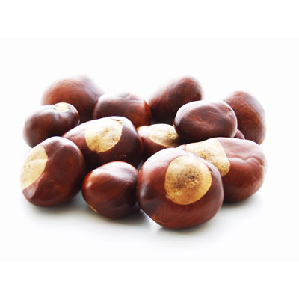
“My family eats roasted chestnuts every Christmas and Thanksgiving.”

- Fairy (noun)- a tiny flying woman with magical powers, popular in children’s stories
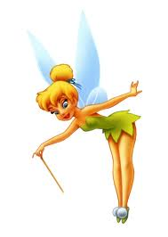
“In American culture, children put their baby tooth under their pillow for the
Tooth Fairy to replace the tooth with money.”

- Glide (verb)- to move easily, quietly, without trying hard
“We glided down the ice without falling when we went ice skating.”

- Grand (adjective)- great, wonderful, idealistic (old fashioned)
“The Grand Canyon is the most beautiful sight I’ve ever seen.”

- Lovely (adjective)- beautiful, satisfying to the eye, heart, or mind
”That is such a lovely photo of you in that beautiful dress!”

- Nearly (adverb)- almost
“I nearly fell down when I slipped on the ice.”

- Sleigh (noun) - a vehicle used for transporting people over snow or ice, sometimes by horses.
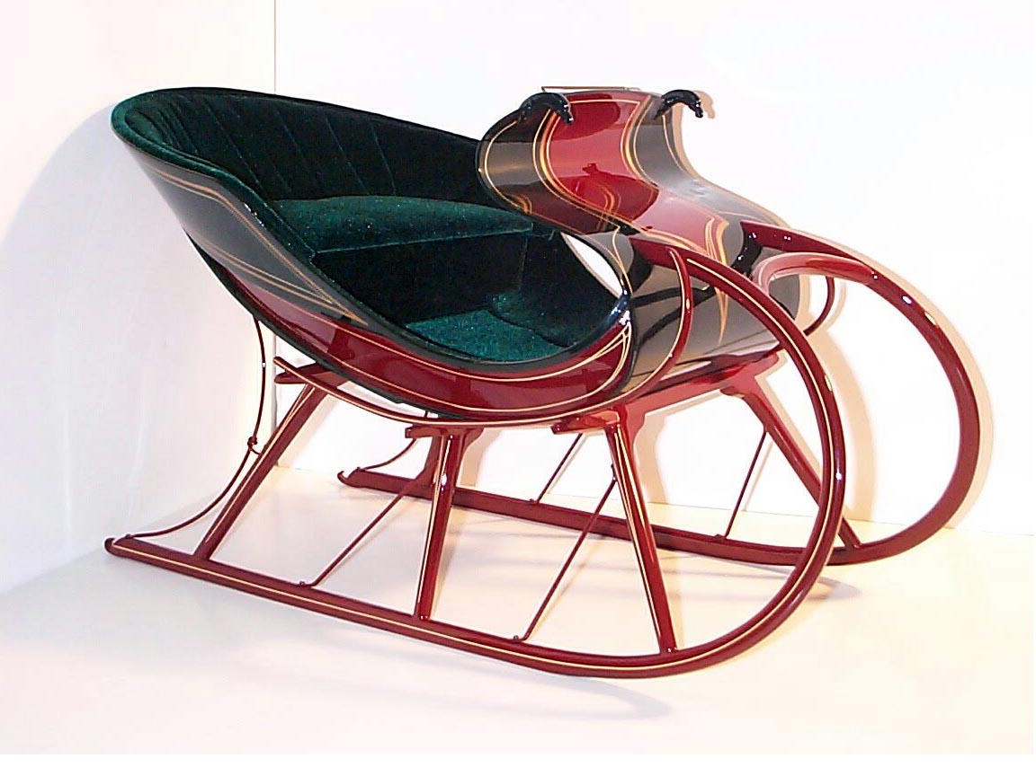
“We need a sleigh with horses to get through this heavy snow!”

- Snuggle (verb) - to cuddle with someone/something; to press closely next to someone/something for comfort or affection.
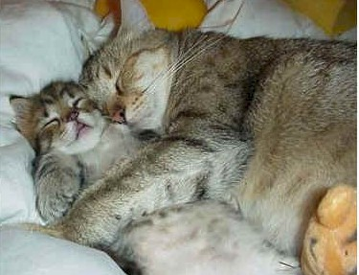
“I like to snuggle with my dog while watching TV.”

- “Giddy-up!” (command verb) - a command people use to get a horse to go faster.
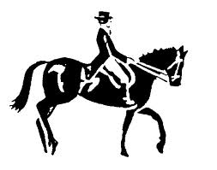
- “Two birds of a feather” (expression)- two people/things that are similar in
some way
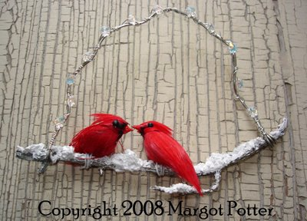
“My best friend and I are two birds of a feather- we are like twins!”

- “Currier & Ives-” artists who made pictures of everyday American life in
the 1800s
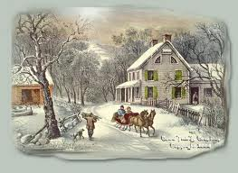 (Example of a Currier & Ives picture print)
“Sleigh Ride”
Music and Lyrics by Johnny Mathis

Directions: Please fill in the blanks with the words you hear.

- Just _________ those _________ bells jingling, ring-ting-tingling too
- ___________, it's ________ weather for a ________ ride together with you
- Outside the _________ is falling and friends are calling "You-hoo!"
- ___________, it's ________ weather for a ________ ride together with you

- Giddy-up, giddy-up, giddy-up, _________, let's look at the show
- We're riding in a wonderland of _________.
- Giddy-up, giddy-up, giddy-up, it's _________, just holding your hand
- We're _________ along with a song of a wintery _________ land

- Our cheeks are ________ and rosy and comfy _________ are we
- We've _________ close _________ like two birds of a feather would be
- Let's take that road before us and sing a chorus or two
- __________, it's ________ weather for a _________ ride together with you

- There's a birthday __________ at the home of Farmer Gray
- It'll be the perfect ending of a perfect _________
- We'll be singing the _________ we love to sing without a single stop
- At the fireplace where we'll watch the _________ pop
- Pop! Pop! Pop!

- There's a __________ feeling nothing in the world can buy
- When they pass around the __________ and the pumpkin pie
- It'll _________ be like a _________ print by Currier and Ives
- These wonderful things are the things we __________ all through our li-ives
- These wonderful things are the things we __________ all through our lives

- Just _________ those _________ bells jingling, ring-ting-tingling too
- __________, it's ________ weather for a _________ ride together with you
- Outside the __________ is falling and friends are calling "You-hoo!"
- __________, it's ________ weather for a _________ ride together with you

- Giddy-up, giddy-up, giddy-up, __________, let's look at the show
- We're riding in a wonderland of ___________.
- Giddy-up, giddy-up, giddy-up, it's _________, just holding your hand
- We're _________ along with a song of a wintery _________ land

- ________ and rosy and comfy _________ are we
- We've _________ close _________ like two birds of a feather would be
- Let's take that road before us and sing a chorus or two
- __________, it's ________ weather for a _________ ride together with you
- _________ weather for a _________ ride together with you
- _________ weather for a _________ ride together with. . .
- _________ weather for a _________ ride together with. . .
- _________ weather for a _________ ride together with. . .

Graphic Organizer: Lyric/Poem Mood Comprehension
Directions: Please write vocab words/phrases/lines from “Sleigh Bells” lyrics and the corresponding mood these words create:

Words / Phrases / Lyric Line | Mood
- Sleigh bells ringing, jingling too  - “Giddy-up, Giddy-up, Giddy-up, let’s go!”  - Gliding along | Happy movement
- Cozy
- Snow is falling
- Lovely weather
- Wonderland
- Wintery fairy land
- Friends are calling “Yoo-hoo!”

- It’ll nearly be like a picture print by Currier & Ives
- At the fireplace
- Chestnuts pop! pop! pop!
- It’s grand just holding your hand
- We’ve snuggled close together
- Like two birds of a feather

Literary Terms
MOOD
The mood is the feeling created in a literary work (song, poem, story, etc.). The choice of setting, objects, actions of the characters/people, details, pictures, and words all create a specific mood. For example, an author may create a mood of sadness in a story about a little boy who dies. The mood of the work often makes the reader feel the emotion that the author is trying to express.

