Math Graphic Organizer
Name: __________________________________________
Math Topic _____________________________________
What math (formulas/topics) do I need to know for this?

What do I need to find out? What are they asking me to do?

What basic math operation/s will I use? 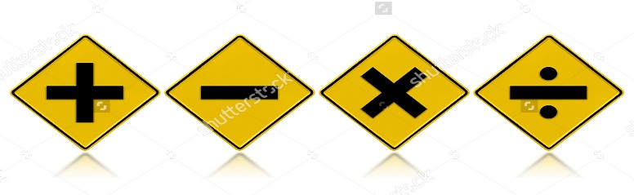
X^{n} 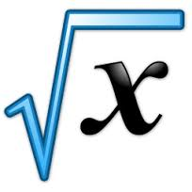

MATH VOCABULARY & PHRASES:

GENERAL ENGLISH VOCABULARY & PHRASES:

My answer is:

ADDITION / ADDING / ADD | SUBTRACTION / SUBTRACTING / SUBTRACT
MULTIPLICATION / MULTIPLYING / MULTIPLY | DIVISION / DIVIDING / DIVIDE

