Math Graphic Organizer
Name: __________________________________________
Math Topic _____________________________________
What math (formulas/topics) do I need to know for this?

What do I need to find out? What are they asking me to do?

What basic math operation/s will I use? 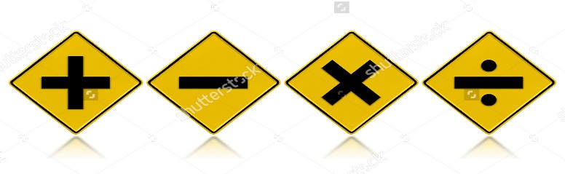
X^{n} 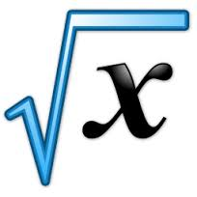

MATH VOCABULARY & PHRASES:

GENERAL ENGLISH VOCABULARY & PHRASES:

My answer is:

ADDITION  - ADD  - PLUS  - SUM  - MORE / MORE THAN  - TOTAL  - GREATER THAN | SUBTRACTION  - SUBTRACT  - MINUS  - DIFFERENCE  - LESS THAN  - LESS  - FEWER
MULTIPLICATION  - MULTIPLY  - TIMES  - PRODUCT  - (DOUBLE X2)  - (TRIPLE X3) | DIVISION  - DIVIDE  - DIVIDED BY  - QUOTIENT  - HALF (/2)  - THIRD (/3)  - QUARTER (/4)  - PER  - FRACTION

