VOCABULARY WORKSHEET

Vocabulary Word / Phrase | Part of Speech | Definition / Meaning / Synonym | Drawing | Antonyms | Collocations | 1. The sentence from the text goes here
 |  |  |  |  |  | 2. Your own sentence goes here
Create | Verb | Make, produce, especially from nothing | 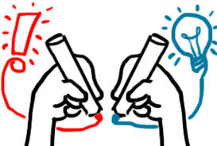 | Destroy | Nothing, OR  By | - When Leonardo DaVinci created the “Mona Lisa,” it was not famous at first.
 |  |  |  |  |  | - I like to create my own stories.
VOCABULARY WORKSHEET

Vocabulary Word / Phrase | Part of Speech | Definition / Meaning / Synonym | Drawing | Antonyms | Collocations | 1. The sentence from the text goes here
 |  |  |  |  |  | 2. Your own sentence goes here

