Name_____________________________ Per______________ Date________________

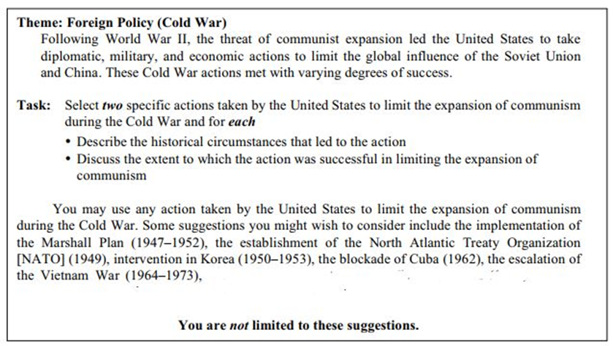

INTRODUCTION:
Following World War II, the threat of communist expansion led the United States to take diplomatic, military, and economic actions to limit the global influence of the Soviet Union and China. These Cold War actions met with varying degrees of success. I will write about two actions: the Marshall Plan and Cuba.
BODY PARAGRAPH #1:
One action taken by the U.S. during the Cold War was the Marshall Plan. One historical circumstance leading to the Marshall Plan was the destruction of European countries in World War II. This action limited communism by giving these countries the money they needed to rebuild after World War II so that they didn’t become Communist. In my opinion, the Marshall Plan was beneficial/not beneficial because _______________________________.
BODY PARAGRAPH #2:
Another action taken by the U.S. during the Cold War was the blockade of Cuba. One historical circumstance leading to this action was that Fidel Castro took over Cuba and made it a communist country. The United States tried to limit Communism by putting a trade and travel embargo with Cuba. This action limited the spread of communism by stopping the spread of people and resources. In my opinion, the Cuban blockade was beneficial/not beneficial because _______________________________.
In conclusion, the danger of Communism made the United States try to stop Communism in other countries like the Soviet Union, Europe, China, and Cuba. In the future, I hope that all countries find a way to make sure all citizens have what they need without military or international invention.

GUIDELINES FOR GLOBAL THEMATIC ESSAY:
INTRODUCTION:
- Copy the Theme here
- End with: “I will write about…………..” (two specific actions: _____ and ________).

BODY PARAGRAPH #1:
- Answer all bullet points in the TASK of the first thing from the task
- (The first action: The Marshall Plan)

BODY PARAGRAPH #2:
- Answer all bullet points in the TASK of the second thing from the task
- (The second action: Cuba)

CONCLUSION:
- Write the theme again here but in different words
- End with: “In the future, I hope _______”

