Name_____________________________ Per______________ Date________________
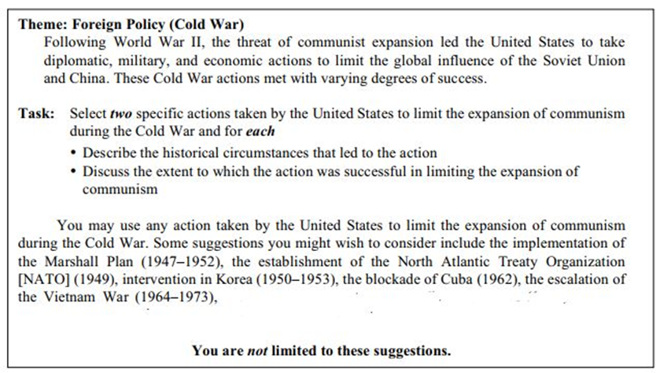
________________________________________________________________________________________________________________________________________________________________________________________________________________________________________________________________________________________

One action taken by the U.S. during the Cold War was the ________________________One historical circumstance leading to the ____________________________was ______________________________________________
____________________________________. This action limited Communism by ____________________ ____________________________________________________.
In my opinion,__________________________________________________________
______________________________________________________________________________.

Another action taken by the U.S. during the Cold War was the_____________________________________________________________. One Circumstance leading to this was________________________________ ___________________ _______________________________________________________. This action was successful in preventing the spread of communism _ ________________________________________________________________________________
____________________________________________________________________________
In my opinion, ______________________________________________________
_____________________________________________________________________________
___________________________________________________________________________.

In conclusion, ___________________________________________________________________________________________________________________________________________________________________________________________________________________________________________________________________________________________________________________________________________________________________________________________________________________________________

