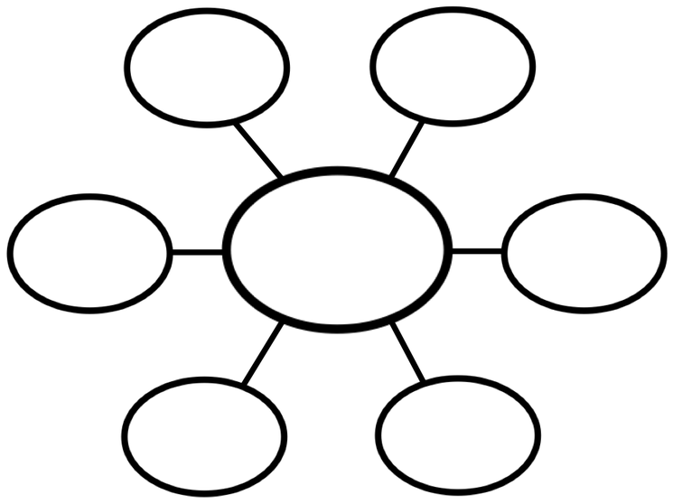

**Write word here**

**Write word here**

**Write word here**

**Write word here**

**Write word here**

**Write word here**

**Write word here**

**Write word here**

**Write word here**

**Write word here**

**Write word here**

**Write word here**

**Write word here**

**Write word here**



**Write word here**

**Write word here**

**Write word here**

**Write word here**

**Write word here**

**Write word here**

**Write word here**